Франко Тальяро – координатор (Италия) научно-методического совета Ассоциации специалистов по химико-и судебно-химическому анализу

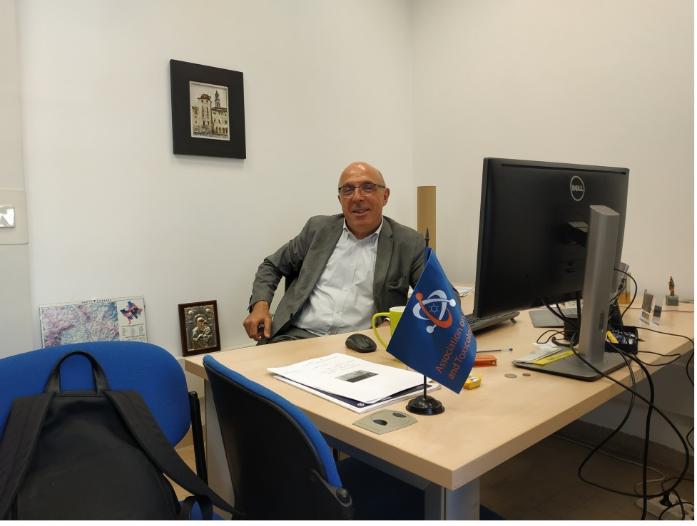

Franco Tagliaro, born in Verona, Italy, on June 8, 1952.
Presently:
- full professor and chair of forensic medicine and toxicology at the University of Verona, Verona, Italy
- head of the Unit of Forensic Medicine at the Verona Central Hospital “G.B. Rossi”
- director of the PhD program n Nanosciences and Advanced Technologies
- director of the post-doctoral school in Legal Medicne
Studies
- 1978: graduation in Medicine with full marks and honours at the University of Padua.
1981: post-doc degree in Biochemistry and Clinical Chemistry with full marks at the University of Parma.
- 1988: post-doc degree in Forensic Medicine with full marks and honours at the University of Verona.
Academic and professional activity
- 1978-1984: research fellow at the Institute of Chemistry, University Hospital of Brescia, and at the Institute of Medical Semeiotics, University of Verona.
1984-1998: pathologist (from assistant to deputy director) at the Institute of Forensic Medicine, University of Verona.
1998-2001: associate professor of Forensic Medicine at the Catholic University of the Sacred Heart, Rome, Italy.
2002-present: Full Professor of Forensic Medicine at the University of Verona.
2003-present: Head of the Unit of Forensic Medicine of the Dept. of Public Health and Community Medicine, University of Verona,
2003-2012: head of the PhD Program in Forensic Medicine and Science, University of Verona.
since 2013: Director of the Graduate School of Translational Biomedical Sciences, University of Verona
International lecturing and academic appointments
- 1995-2005, Visiting Professor at the Graduate Program in Forensic Science, The University of Alabama at Birmingham (UAB), Birmingham, AL, USA.
- 2006-present, “professor on ad hoc contract” at the University of New Haven, New Haven CT, USA.
- December 1998, lecturer and instructor in a two-weeks post-doc program at the “Naif Arab Academy for Security Sciences”, Riyadh, Arabia Saudita.
- since 1999 until present, international referee for academic promotion of the Academic Council, King Saud University, Riyadh, Saudi Arabia.
- 2001 member of the “beoordelingscommissie” for PhD graduation at the RijksUniversiteit, Groningen, The Netherlands.
- 2001, international member of the committee for PhD graduation, at the Glasgow University, Glasgow, Scotland.
- 2010, international member of the committee for PhD graduation, at the University of Amsterdam, Amsterdam, The Netherlands.
- since 2011 is foundation fellow of the Academy of Forensic Medical Sciences.
- since 2015 is foreign referee in the Greek system of evaluation for the academic promotion
- since 2015 is foreign evaluator for the Czech Academy of Sciences
Editorial activity
- Member of the Editorial Boards of the following scientific journals:
“Forensic Science International” (since 1996),
“Journal of Chromatography B” (1998-2008),
“Forensic Science Journal” (since 2010),
“Rivista Italiana di Medicina Legale e del Diritto in Campo Sanitario” (since 2013).
- Since 2009 is co-editor of “Bollettino per le Farmacodipendenze e Alcolismo”.
- Since 2010 is International Consulting Editor of “Medicine Science and The Law”.
- Regular referee for “Journal of Chromatography A”, “Journal of Chromatography B”, “Forensic Science International”, Medicine, Science and The Law”, “Journal of Separation Sciences”, “Electrophoresis”, “Clinical Chemistry”, “Journal of Analytical Toxicology”, “Alcohol”, “Alcohol and Alcoholism” e “Clinica Chimica Acta”.
Humanitarian activity
May 2002, forensic pathologist in the humanitarian mission to Kosovo organized by CIFA (Centre for International Forensic Assistance, University of Glasgow) in cooperation with UNMIK (United Nations Mission in Kosovo).
Fund raising
Dr. Tagliaro obtained research funding from the following Institutions:
Italian CNR (years 1984-1987), United Nations Interregional Crime and Justice Research Institute (years 1992-1993), Regione Veneto (years 1994 and 1997), Fondazione Cassa di Risparmio di Verona, Vicenza, Belluno e Ancona (year 1997, 2006, 2008), Ministry of University and Research (MIUR) (years 1999-2001, 2001-2003, 2003-2005, 2005-2007, 2007-2009), Department for the Antidrug Policies, Office of the Prime Minister (years 2010-2014, 2014-2016).
Affiliation to Scientific Societies
Since 1987 until present Dr. Tagliaro is member of the Italian Society of Legal Medicine (SIMLA) and since 1988 is member of the "Forensic Toxicologists Group” (GTFI).
Since 1989 until present he is member of "The International Association of Forensic Toxicologists” (TIAFT).
Acknowledgments
- 1002-1993, “Ad hoc consultant” of the United Nations Interregional Crime and Justice Research Institute (UNICRI), Rome.
- 1994, “Ad hoc advisor” of United Nations International Drug Control Programme (UNDCP).
- To Dr. Tagliaro the Editor’s Page of Journal of Capillary Electrophoresis was dedicated (issues 3&4, vol. 5, 1998).
- October 20-22. 2009: delegate of the Department for the Illicit Drug Control Policies, Office of the Prime Minister, Rome, at the Technical Consultation “Workplace Prevention: Promoting Health and Preventing Substance Abuse” at the United Nations Office on Drugs and Crime (Vienna International Centre, Vienna).
- November 21-22, 2011, delegate of the Department for the Illicit Drug Control Policies, Office of the Prime Minister, Rome, at the “Second Meeting of the ad hoc expert group on the prevention of drug use in the work-place” Groupe Pompidou, Conseil de l’Europe (Strasbourg).
- February 9-10, 2012, delegate of the Department for the Illicit Drug Control Policies, Office of the Prime Minister, Rome, at the “Third Meeting of the ad hoc expert group on the prevention of drug use in the work-place”, Groupe Pompidou, Conseil de l’Europe (Strasbourg).
- Editorial in Journal of Chromatography A, 83, 1287 (2013) on F. Tagliaro’s article “New challanges and innovation in forensic toxicology: focus on the New Psychoactive Substances”, J. Chromatogr. A 84-95, 1287 (2013)
- 2009-present, advisor of the Department for the Illicit Drug Control Policies, Office of the Prime Minister, Rome.
Research subjects
- Calcium metabolism and calciotropic hormones: bone and mineral metabolism; pain perception; calcitonin physiology, pharmacology, neuroendocrine regulation and a proposed role as a neuropeptide.
- Changes in hormone and neuropeptide levels in heroin addicts: sexual hormones, beta–endorphin, calcitonin.
- Changes of analgesic peptides (beta-endorphin and calcitonin) in stressing and painful situations: in delivery or induced by hypnosis.
- Development of radiometric and chromatographic methods, for the determination of steroidal or peptidic bio-active compounds. Vitamin D metabolites, beta–endorphin, ACTH, calcitonin.
- Development of immunological, chromatographic and spectrometric methods for the determination of abusive and therapeutic drugs and toxic compounds in biological samples, including hair. Morphine determination by TLC, immunometry, HPLC, collisional spectroscopy. Morphine and cocaine analysis in hair. Teophyilline, dyphylline, doxofylline and caffeine. Amanita toxins. 2,5-hexanedione.
- Applications of immobilized antibodies and enzymes in HPLC. Sample pre-treatment with immobilized antibodies (anti-morphine, anti-calcitonin, anti-amanitins). Post column reactors with immobilized alcohol oxidase allowing the HPLC/EC determination of ethanol and methanol.
- Biomedical and toxicological applications of capillary electrophoresis. Analysis of peptides, amino acids, therapeutic and illicit drugs including chiral compounds, DNA fragments, carbohydrate deficient transferrin (CDT), organic acids etc.
- Combined use of capillary electrophoresis with high resolution mass spectrometry.
The scientific production of Dr. Tagliaro includes:
• more than 200 papers "in extenso", 126 of which with I.F.
• 9 monographic books or volumes with international distribution.
• more than 200 lectures given at International/National Symposia or Congresses, available as abstracts.
Impact of the scientific work of Dr. Tagliaro:
at the end of year 2015, the H Index of Dr. Tagliaro was 31 (Scopus).

